**Emkan Finance**

Migration

Origination Flow

**Draft2**

**August 17, 2024**

Contents

**Document Version History** 3

**Document Review & Approval History** 3

**Document References** 3

**Introduction** **Error! Bookmark not defined.**

**Scope** **Error! Bookmark not defined.**

**Assumption** **Error! Bookmark not defined.**

**High Level Business Requirements** 4

**Architecture Overview** 5

1. Diagram 5

2. Description 6

**Execution Flow View** 8

.1. Configuration 8

1. Onboarding Flow 9

2. Dashboard Flow 16

3. Loan Eligibility Flow 21

4. KYC **Error! Bookmark not defined.**

5. Create Application and Loan Eligibility check ) 34

6. App Date Entry Flow **Error! Bookmark not defined.**

7. Upload Document Flow 35

8. Loan Offering Flow **Error! Bookmark not defined.**

9. Loan Execution Flow **Error! Bookmark not defined.**

Entity Relation: **Error! Bookmark not defined.**

**Deployment and Security View** 36

Appendix A - Architectural Decisions 36

1. Using IVR as BL before NE **Error! Bookmark not defined.**

1. Using Shedlock to handle schedular **Error! Bookmark not defined.**

Appendix D – Failing Retry Policy 38

Appendix E – Cooling Period 39

Appendix R – Risks 39

Appendix I – General Impacts 39

# **Document Version History**

|  |  |  |  |
| --- | --- | --- | --- |
| **Ver** | **Date** | **Author** | **Change Description** |
| 0.1 | 17/03/2024 | Ishaq | Draft |
| 0.2 | 05/08/2024 | Mohamed Hosni | add work flow diagram  Update Onboarding Flow Diagram  Add create lead diagram  Update CRM diagrams  Add product eligibility Diagram  Add uploads Document Diagram  Update dynamics and Kafka Description |
| 0.3 | 07/08/2024 |  | Add product eligibility Diagram  Add uploads Document Diagram  Update dynamics and Kafka Description |

Table 2 Document Version History

# **Document Review & Approval History**

|  |  |  |  |  |
| --- | --- | --- | --- | --- |
| **Version** | **Reviewer** | **Approver** | **Review Date** | **Approval Date** |
| 0.1 |  |  |  |  |
|  |  |  |  |  |

Table 3 Document Review & Approval History

# **Document References**

|  |  |
| --- | --- |
| **Document Name** | **Document Link** |
|  |  |

**Acronym Defintion**

|  |  |
| --- | --- |
| **Acronym** | **Description** |
| ARB | Al Rajhi Bank |
| API | Application Programming Interface |
| OTP | One Time Password |
| BAU | Business as Usual (already implemented / As is) |
| MS | Microservice |
| AML | Anti-Money Laundering |
| IVR | Interactive Voice Response |
| SAMA | Saudi Central Bank |
| SIMAH | Saudi Credit Bureau |
| MOV | Minimum/Maximum Order Value |

**System Roles**

List of all related systems and their roles as per the solution

|  |  |
| --- | --- |
| **System** | **Role** |
| **Mobile App** | Customer Interface |
| **Emkan Services** | Integration , Business and Mobile BE Services |
| **Kastle** | Loan Orignation Banking System(LOS) has following modules:  Product Catalog  LMS Loan management System |
| **Qarar** | Decision Engine Service[third party], it implements a decision engine based on credit bureau data. it implements decision rules to accept, reject or refer card applications. |
| **DMS** | Document Management System |
| **Unifonic** | Third party for sending notification to customer like SMS or IVR |
| **Emkan NE** | Emkan Notification Engine for sending notification like IVR ,SMS, push notification |
| **Emkan Rule Engine** | System to apply rules provide set of rules result |
| **Newgen** | Loan Origination System |
| **T24** | Loan Management System |
| **Middleware** | Integration Layer |
| **CRM** | Master Customer Data |

# **Introduction**

The purpose of this document is covering the architecture of Loan Origination Flow for EMKAN 3 .

# **Scope**

-in scope

* Loan Origination Flow for Emkan 3 Migration Scope

-out of scope

* Kastle journey out of scope and required changes will covered in separate Document

# **Assumption**

* Emkan Registration flow /Login Flow [BAU]
* Emkan Notification Engine [BAU]

# **High Level Business Requirements**

|  |  |  |
| --- | --- | --- |
| ID | JIRA Ref. | Statement of Requirement |
| 1 |  |  |

# **Architecture Overview**

Our architecture will be Mix of the following:

* Micro Service Architecture
* Event Driven Architecture

## Diagram

The below diagram will show how the architecture will be

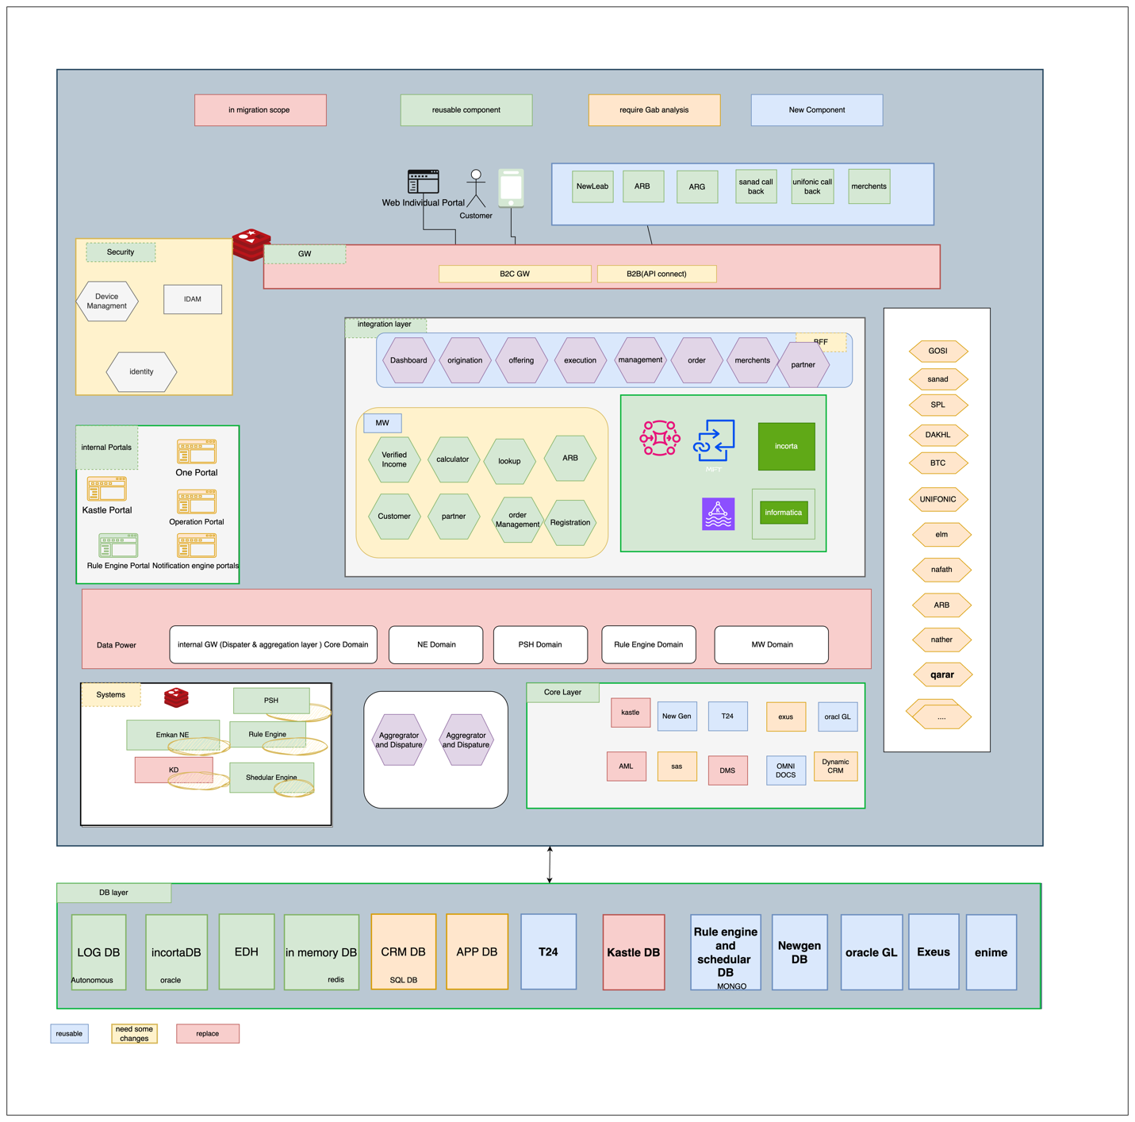

New GWs defined for Migration

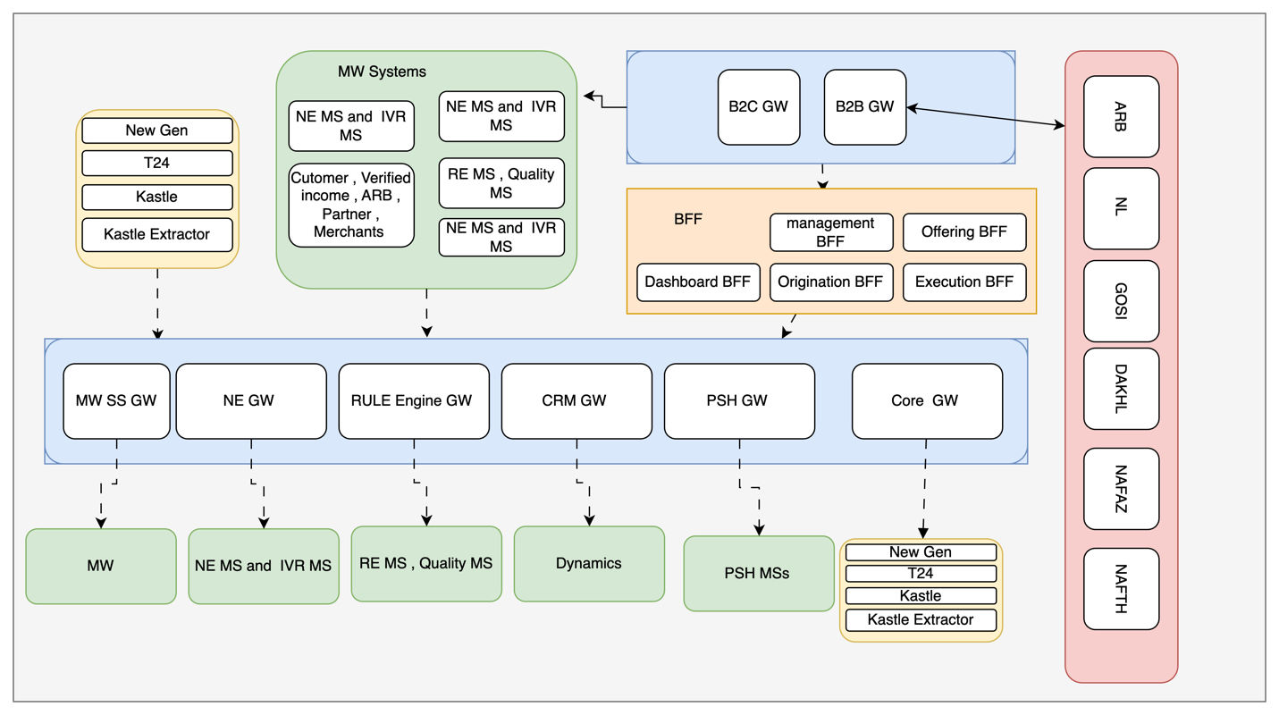

## Description

|  |  |  |
| --- | --- | --- |
| **Layer** | **Service/component** | **Role** |
| **Channels** | Staff | One Portal, Core Systems |
|  | Customer | Emkan Mobile App, Website |
|  | Partners | Merchant Portal, Merchant E-Commerce Platform |
| **Gateway** | B2C  IBM DataPower | Receiving traffic from Channel Customer |
| B2B Gateway | Receiving traffic from Channel Partners |
| IG | Receiving traffic from BFF and Middleware Integration Microservice layer |
| TPP Gateway | To And Fro traffic of Third Party Providers |
| Dashboard | MS for doing transformation , aggregation,segregation ,... related to application dashboard communications like fetching all applications within stattistics from different core banking system,... |
| **Security** | IDAM(WSO2) | Identity Server for  identity and access management, |
| Identity Service | MS for identifying user [authentication/authorization] |
| Device Management | MS for managing registered device of customer |
| **Support Services** | Emkan NE | Notification Engine for sending notification like SMS,IVR, push Notification Message and feeback caller |
| Emkan Scheduler Engine | Scheduler Engine to Handling Job Tasks for Emkan |
| Emkan Rule Engine | Rule Engine to apply Ruel Sets |

# **Execution Flow View**

# Configuration

* + 1. **New Gen Configuration**:
* Configure below stage as unified stages for all products

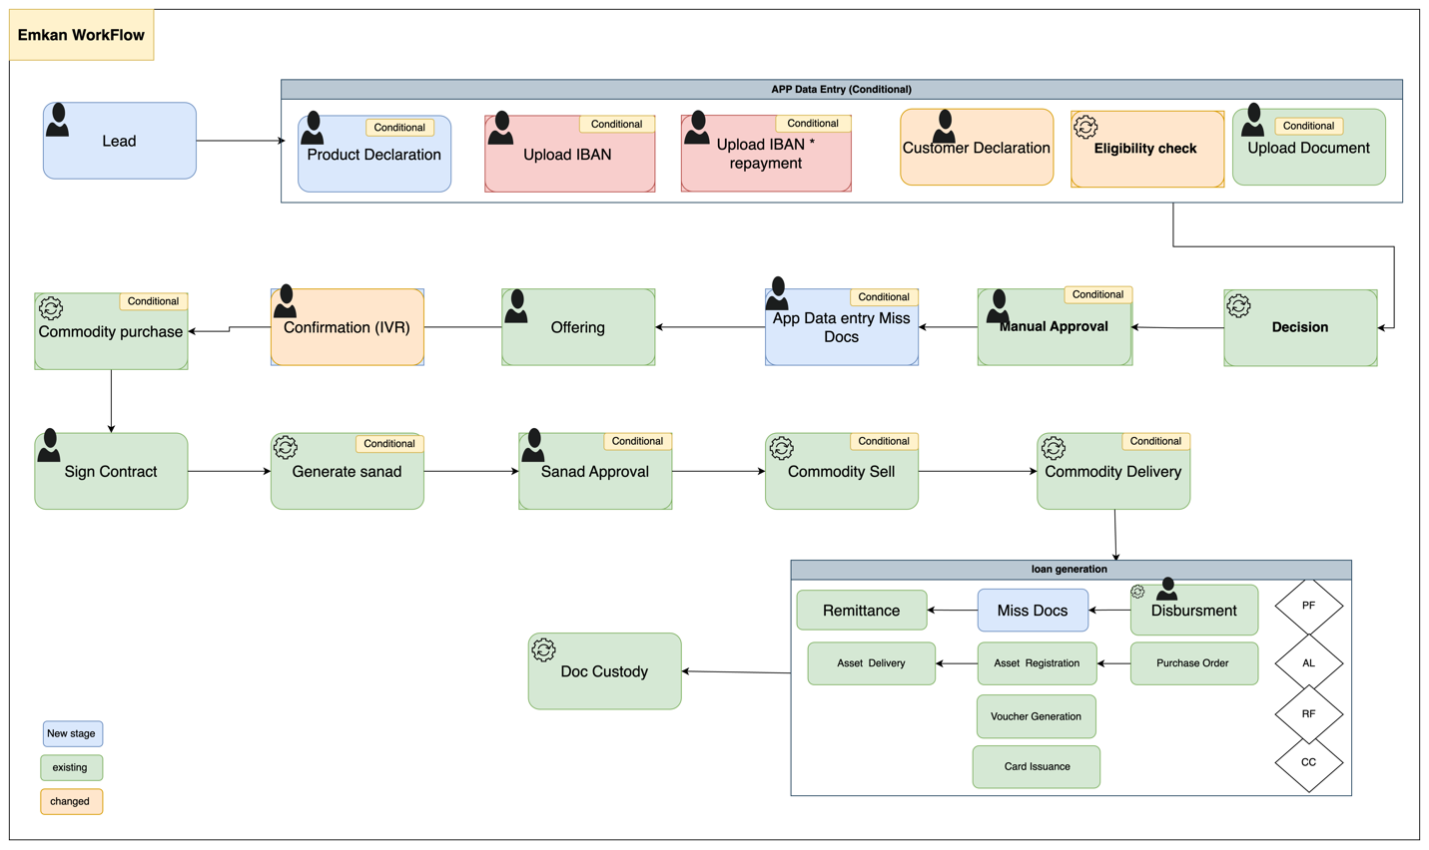

Description:

|  |  |
| --- | --- |
| **Task Name** | **Description** |
| Generate Request | Generating Unique identifier refer to Process-ID or Parent Application ID |
| Loan eligibility | Applying eligibility rules on customer |
| Screening | Checking customer sanction and screening |
| Customer declaration | Customer need to submit all expense, obligations ,income ,employer info , IBAN |
| Generate applications | Generate application[loans] per item |
| Upload Document | Customer submit document required |
| Decision | Final decision and final offer if accepted |
| Customer Offering Approval | Customer decides accept or reject final offer |
| Confirmation stage [IVR] | Triggering IVR call for loan confirmation |
| Commodity purchase maker | Purchasing commodity |
| Repayment Mode | Set repayment mode for customer |
| Sign contract | Customer accept /reject Sign contract of all applications |
| Generate Sanad | System generates PN for customer |
| Sanad Approval | Customer decides accept or reject Sanad |
| Commodity sell maker | Selling commodity |
| Disbursement | Disbursement Stage |
| Remittance | Remittance Stage |
| Document custody | Complete of process |

# Onboarding Flow

1. Diagram

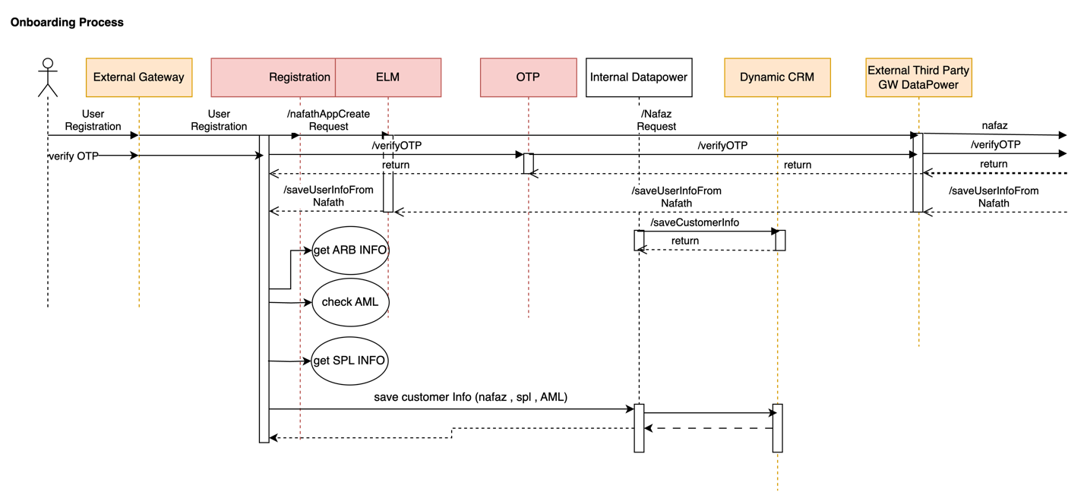

|  |  |  |  |  |  |
| --- | --- | --- | --- | --- | --- |
| **System Provider** | **Action** | **Request** | **Response** | **Type** | **Description** |
| Nafath | /nafathAppCreateRequest | asIs | asIs |  |  |
| OTP | /verifyOTP | asIs | asIs |  |  |
| Registration | /saveUserInfoFromNafath | asIs | asIs |  |  |
| **CRM** | /saveCustomerInfo |  |  |  | Refer IRD  CRM-EMK-DIG001  This api will be exposed by CRM to emkan. Emkan will call this api to save customer related information in Dynamic CRM.  Below objects will be passed as part of this request.  "basicCustInfo","addInfo","salInfo","expInfo","empInfo","autoLeaseCustomerInfo",ibanInfo","buyOutInfo","naInfo","companyInfo","loanDetails"  If any object is null then that information will not be saved in Dynamic CRM. |
| **CRM** | /getCustomerInfo |  |  |  | Refer IRD  CRM-EMK-DIG001  This api will be exposed by CRM to emkan. Emkan will call this api to get customer profile information from Dynamic CRM.  Below objects will be passed as part of this request to fetch customer profile.  "basicCustInfo","addInfo","salInfo","expInfo","empInfo","autoLeaseCustomerInfo","arbAccounts","ibanInfo","buyOutInfo","naInfo","companyInfo","loanDetails"  Objects for which information is not required it should be passed as null. |
| **CRM** | /updateCustomerInfo |  |  |  | Refer IRD  CRM-EMK-DIG001  This api will be exposed by CRM to emkan. Emkan will call /saveCustomerInfo api to update customer profile information in Dynamic CRM.  Any object which need no update will be passed as null.  Below objects will be passed as part of this request to update customer information.  "basicCustInfo","addInfo","salInfo","expInfo","empInfo","autoLeaseCustomerInfo","arbAccounts","ibanInfo","buyOutInfo","naInfo","companyInfo","loanDetails" |
| ARB | /getARBInfo | asIs | asIs |  |  |
| ENME | CheckAML |  |  |  | Refer LOAN-EMK-DIG003 for api Specifications.  Call ENME to verify customer screening process.  Modify AML URL to ENME URL. |
| Newgen | /createCustomer |  |  |  | Refer LOAN-EMK-DIG005 for API Specifications.  Call Newgen to create Customer. |

* 1. – branch flow

1. 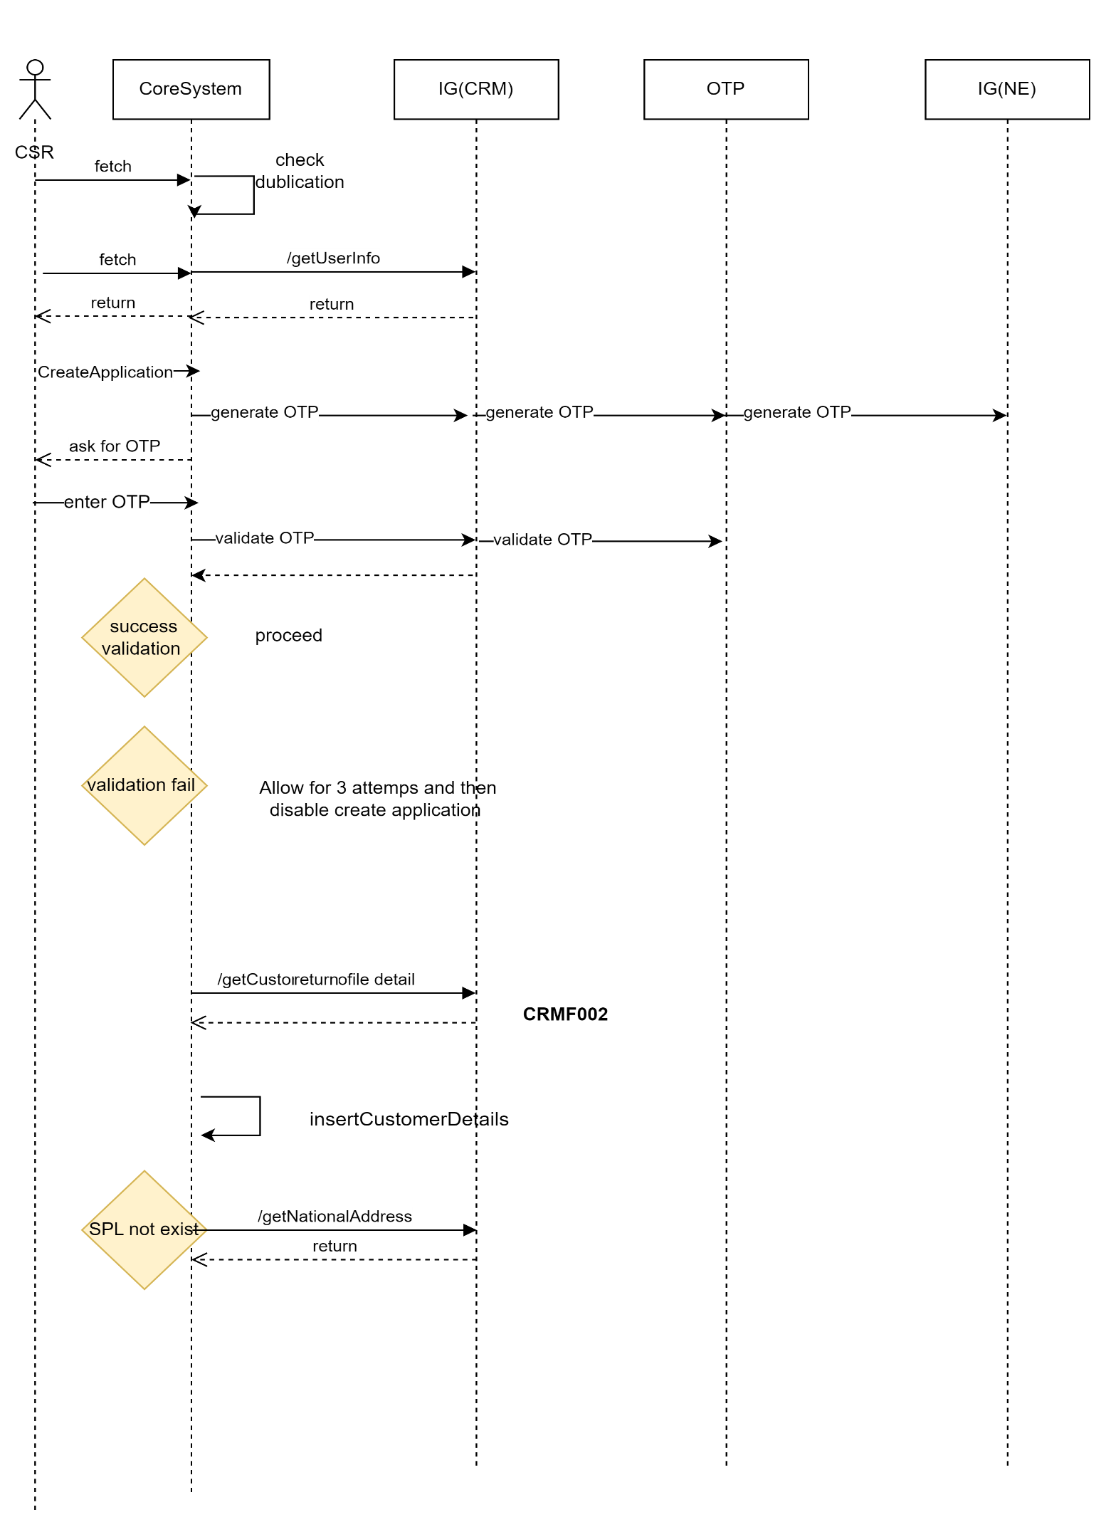
2. Description

|  |  |  |  |  |  |
| --- | --- | --- | --- | --- | --- |
| **System Provider** | **Action** | **Request** | **Response** | **Type** | **Description** |
| Core | /getUserInfo | asIs | asIs |  | If user is registering for first time from branch then call Yakeen and insert information into Emkan_Customer table.  While user registers from Mobile then update Nafath information into Emkan_Customer table. |
| Core | createApplication | asIs | asIs |  | Call Newgen system to create the application |
| OTP | /verifyOTP | asIs | asIs |  |  |
| Customer | /getCustomerProfileDetails | asIs |  |  | This will internally calls /getCustomerInfo to fetch the information from CRM DB. |
| **CRM** | /saveCustomerInfo |  |  |  | Refer IRD  CRM-EMK-DIG001  This api will be exposed by CRM to emkan. Emkan will call this api to save customer related information in Dynamic CRM.  Below objects will be passed as part of this request.  "basicCustInfo","addInfo","salInfo","expInfo","empInfo","autoLeaseCustomerInfo",ibanInfo","buyOutInfo","naInfo","companyInfo","loanDetails"  If any object is null then that information will not be saved in Dynamic CRM. |
| **CRM** | /getCustomerInfo |  |  |  | Refer IRD  CRM-EMK-DIG001  This api will be exposed by CRM to emkan. Emkan will call this api to get customer profile information from Dynamic CRM.  Below objects will be passed as part of this request to fetch customer profile.  "basicCustInfo","addInfo","salInfo","expInfo","empInfo","autoLeaseCustomerInfo","arbAccounts","ibanInfo","buyOutInfo","naInfo","companyInfo","loanDetails" |
| **CRM** | /saveCustomerInfo |  |  |  | Refer IRD  CRM-EMK-DIG001  This api will be exposed by CRM to emkan. Emkan will call this api to update customer profile information in Dynamic CRM.  Any object which need no update will be passed as null.  Below objects will be passed as part of this request to update customer information.  "basicCustInfo","addInfo","salInfo","expInfo","empInfo","autoLeaseCustomerInfo","arbAccounts","ibanInfo","buyOutInfo","naInfo","companyInfo","loanDetails" |
| Customer | /getUserInfo | asIs | asIs |  |  |
| OTP | /sendEmkanOTP | asIs | asIs |  |  |
| NationalAddress | /getNationalAddress | asIs | asIs |  | If user is in nationaladdress cooling period then fetch information from Dynamic CRM  If cooling period is off then fetch information from Saudi Post. |

# Dashboard Flow

1. Diagram

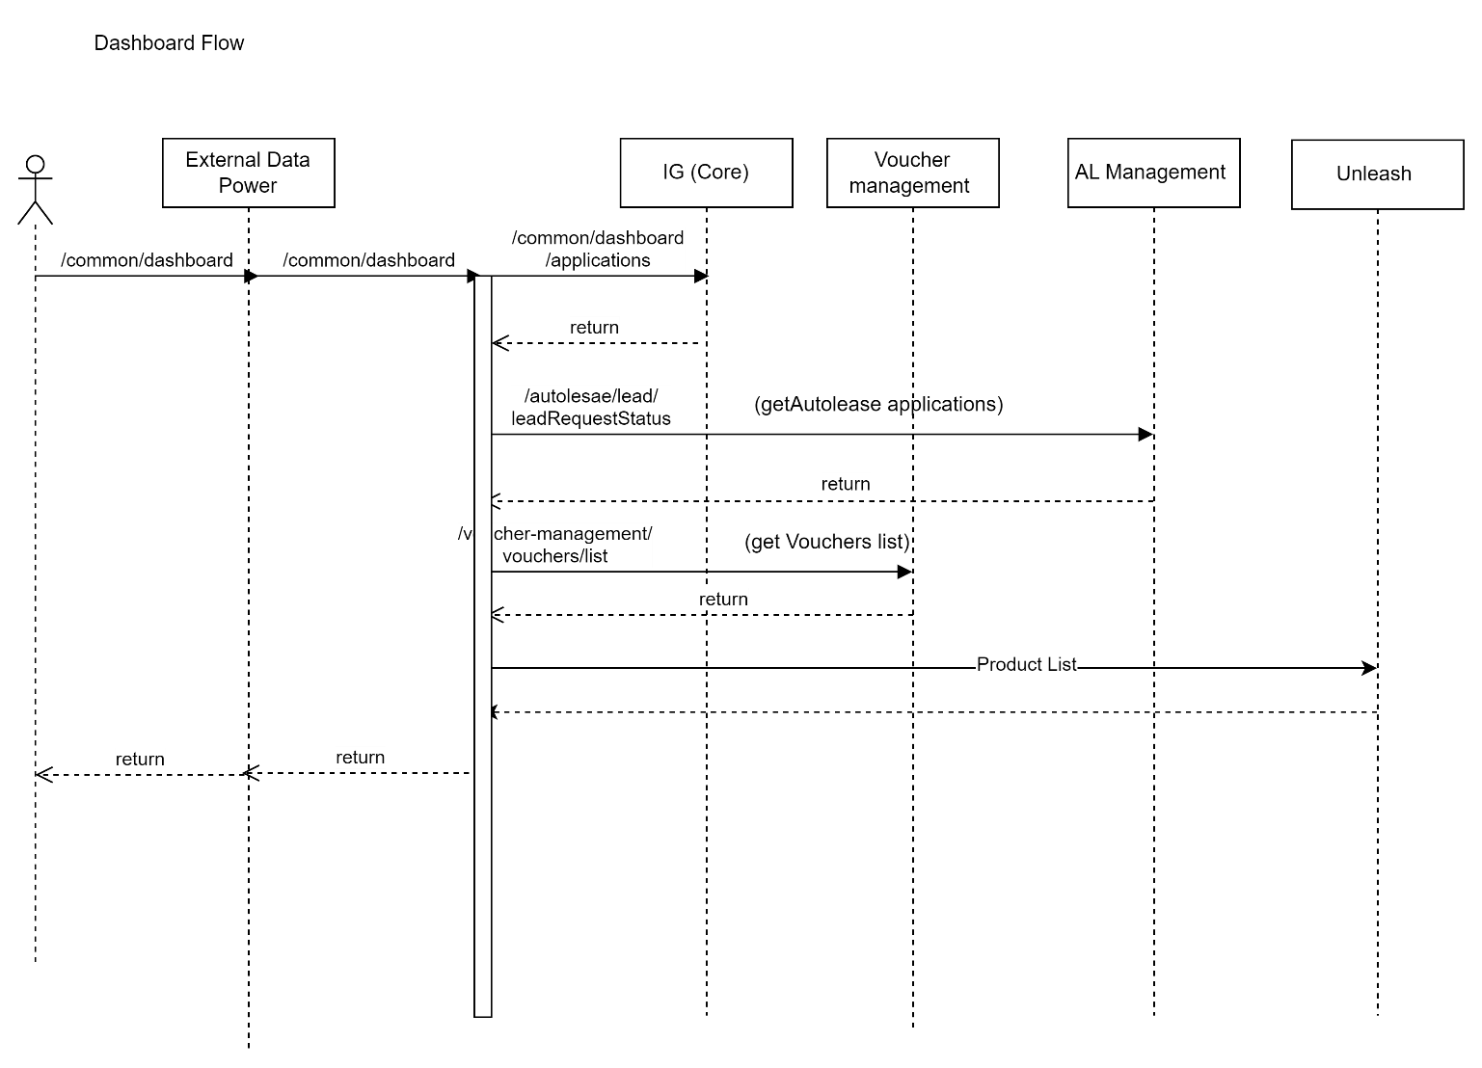

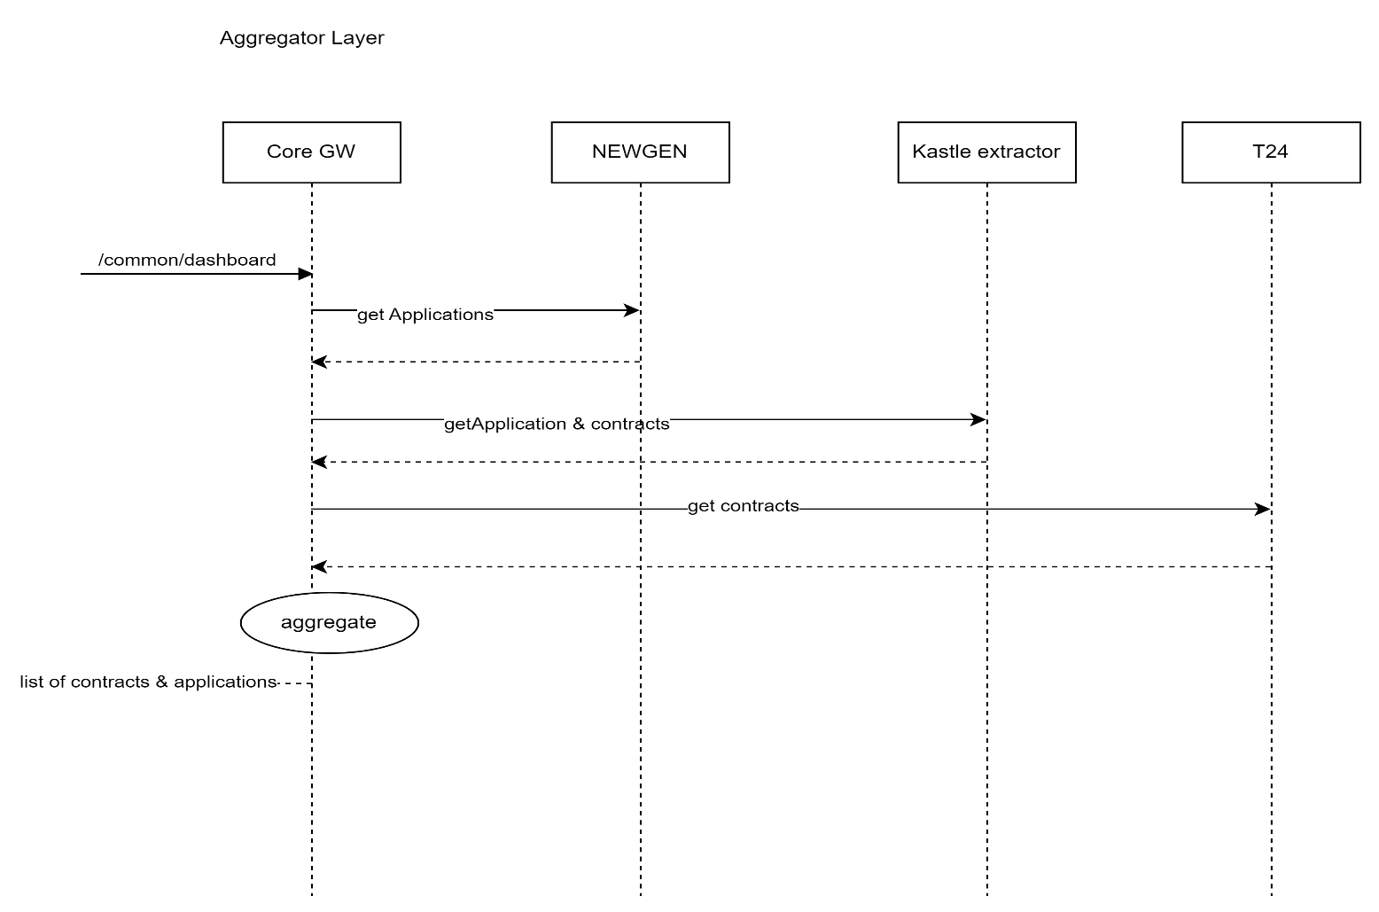

Description:

|  |  |  |  |  |  |
| --- | --- | --- | --- | --- | --- |
| **System Provider** | **Action** | **Request** | **Response** | **Type** | **Description** |
| Dashboard | /common/dashboard | {  "status": "active",  "cifId": "CIF789456",  "nationalId": "NID123456789"  } | {  "id": 123456,  "applicationId": "APP001",  "lastInstallmentDate": "2024-07-15",  "subProduct": "SubProduct A",  "product": "Product A",  "installmentAmount": 500.00,  "stage": "In Progress",  "totalFinancedAmount": 10000.00,  "amountRemaining": 3000.00,  "nextInstallmentDue": "2024-08-15",  "loannumber": "LN123456789",  "status": "active",  "substage": "Underwriting",  "subsourcingChannel": "Online",  "bp": "BP123",  "source": "Web",  "installmentRemainDuration": 5,  "remainingInstallmentNumber": "5",  "reasonCode": "RC001",  "reasonMessage": "Payment overdue",  "reasons": [  {  "reasonCode": "RC001",  "reasonmsg": "Payment overdue"  },  {  "reasonCode": "RC002",  "reasonmsg": "Insufficient funds"  }  ]  } |  | Instead of calling Kastle-Extractor call Integration Layer(Internal Data power) end point which will aggregate response from T24/Kastle/Newgen and send all applications. |
| Autolease | /leadRequestStatus | asIs | asIs |  |  |
| Voucher-Management | /vocucherList | asIs | asIs |  |  |

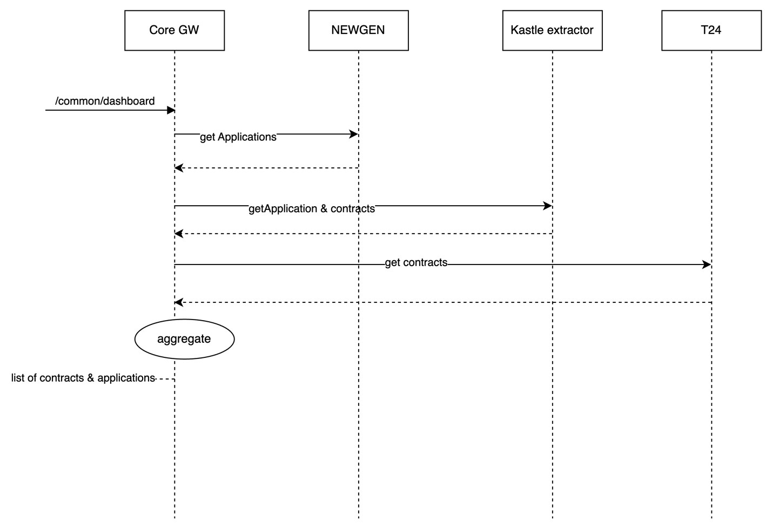

# Loan Eligibility Flow (Lead Generation Flow )

* Diagram

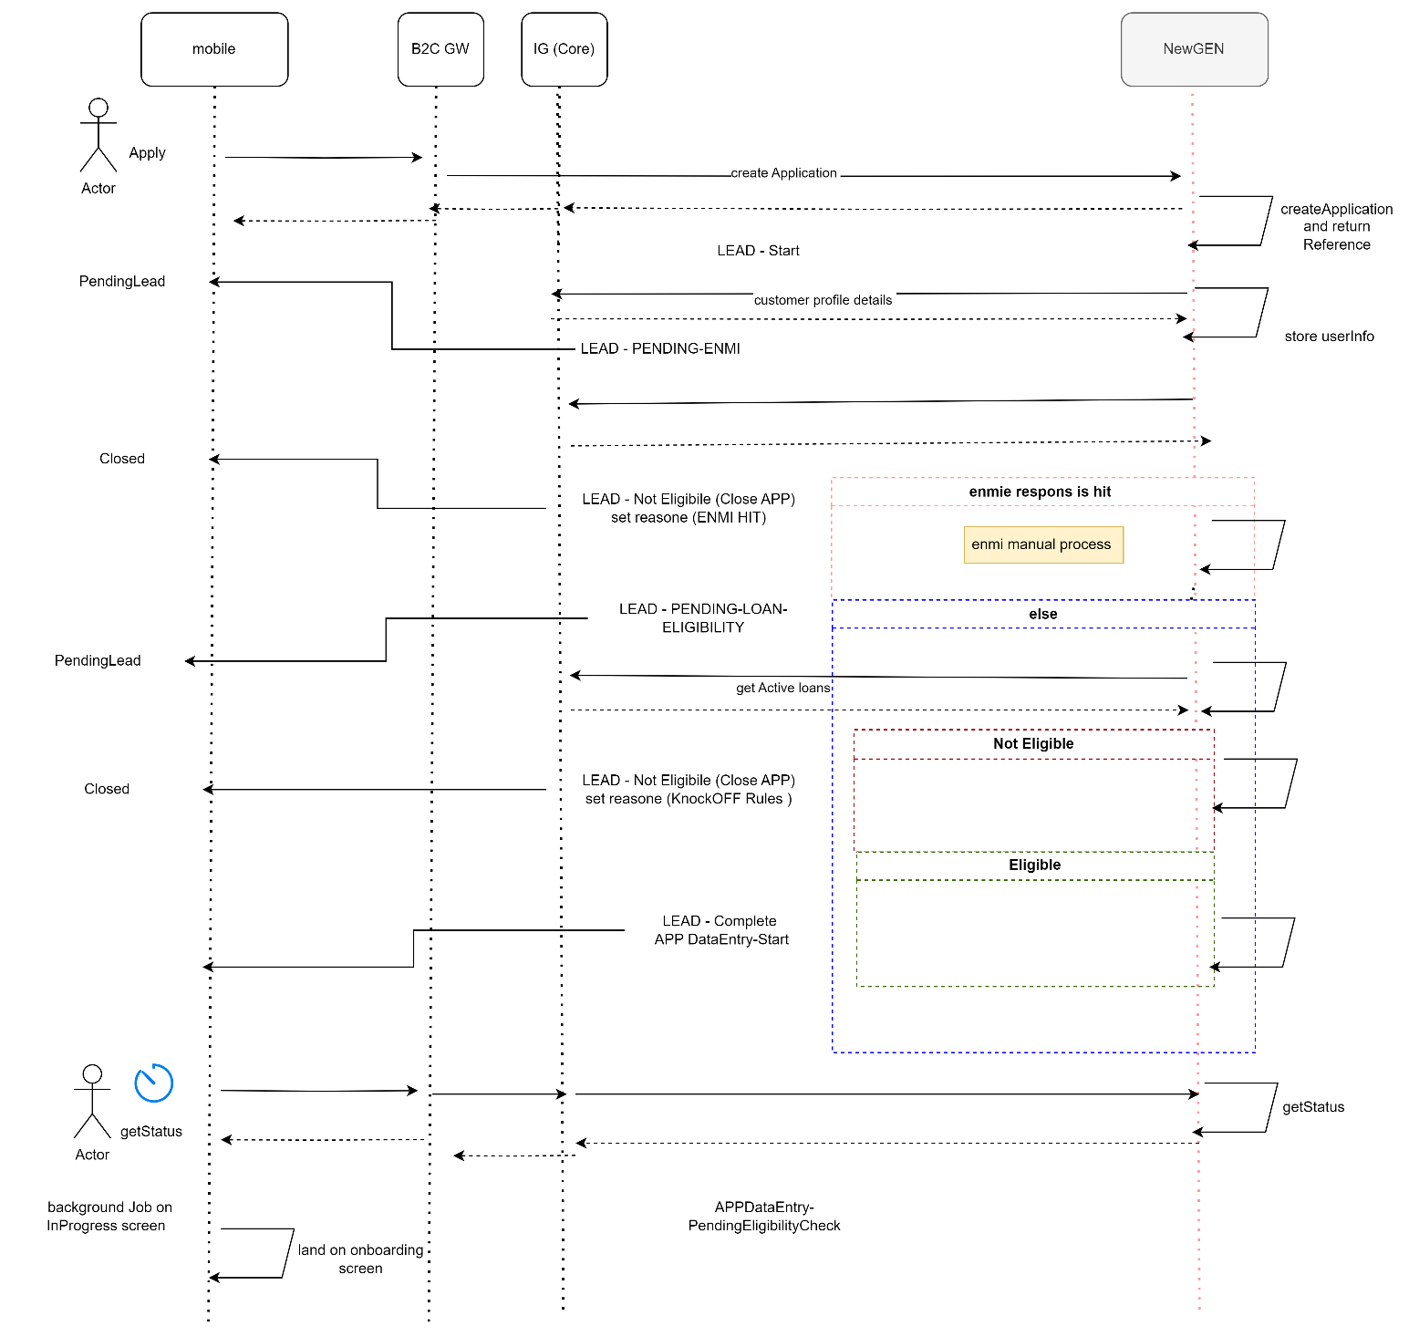

Description:

|  |  |  |  |  |  |
| --- | --- | --- | --- | --- | --- |
| **System Provider** | **Action** | **Request** | **Response** | **Type** | **Description** |
| Customer | /getCustomerProfileDetails | asIs | asIs |  | This will internally calls /getCustomerInfo to fetch the information from CRM DB. |
| **CRM** | /getCustomerInfo |  |  |  | Refer IRD  CRM-EMK-DIG001  This api will be exposed by CRM to emkan. Emkan will call this api to get customer profile information from Dynamic CRM.  Below objects will be passed as part of this request to fetch customer profile.  "basicCustInfo","addInfo","salInfo","expInfo","empInfo","autoLeaseCustomerInfo","arbAccounts","ibanInfo","buyOutInfo","naInfo","companyInfo","loanDetails" |

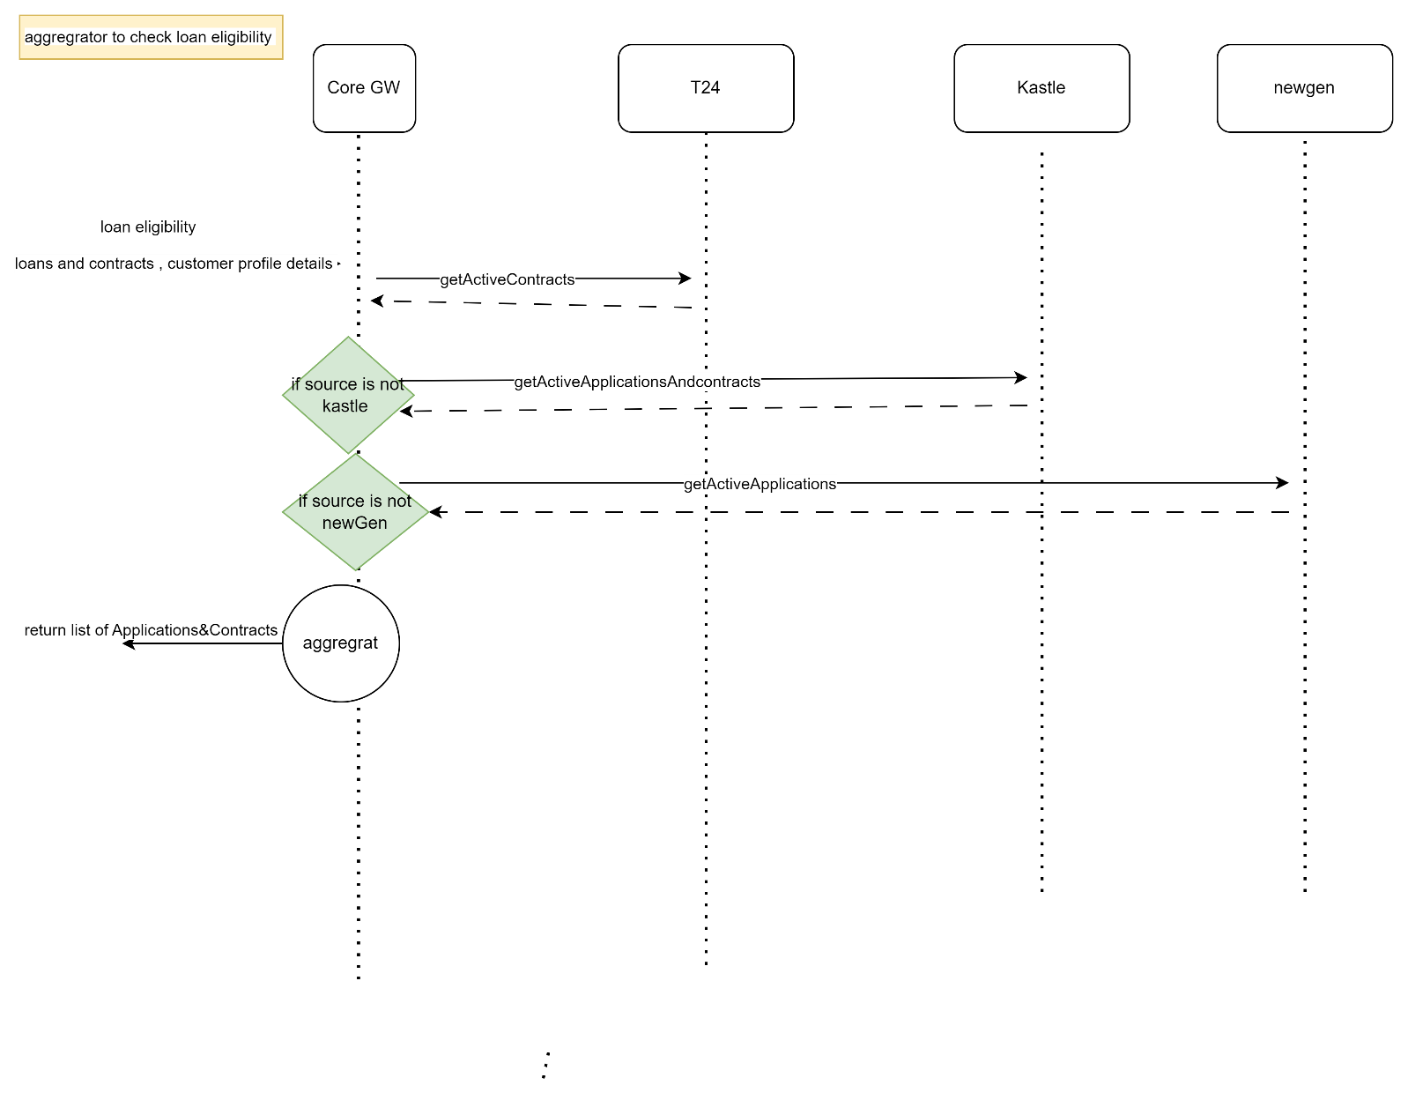

* Description

|  |  |  |  |  |  |
| --- | --- | --- | --- | --- | --- |
| **System Provider** | **Action** | **Request** | **Response** | **Type** | **Description** |
|  |  |  |  |  |  |

# Customer declaration

* Diagram

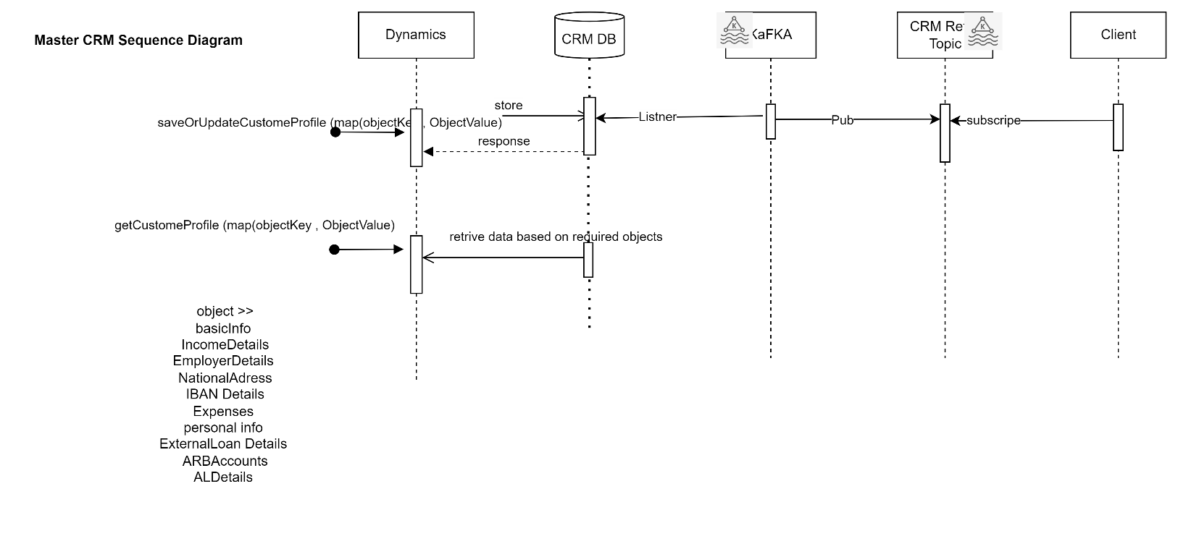

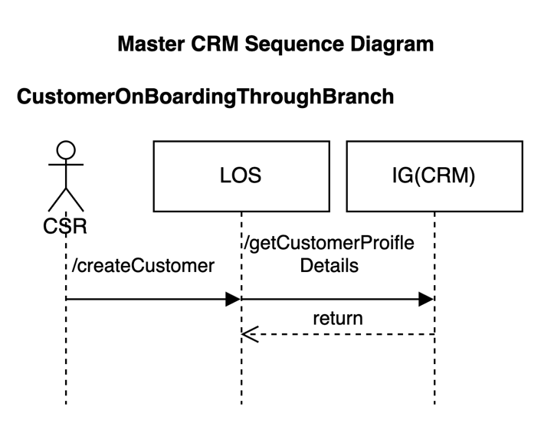

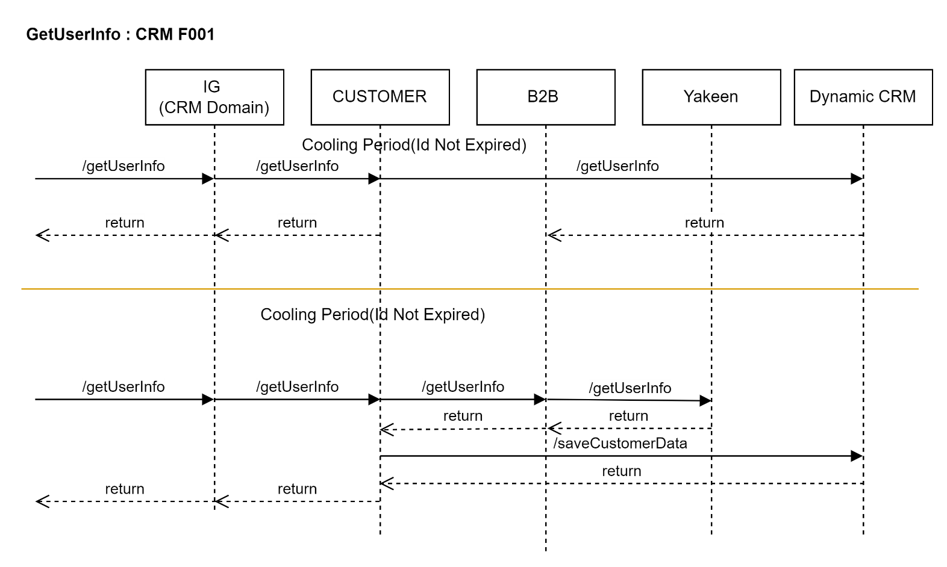

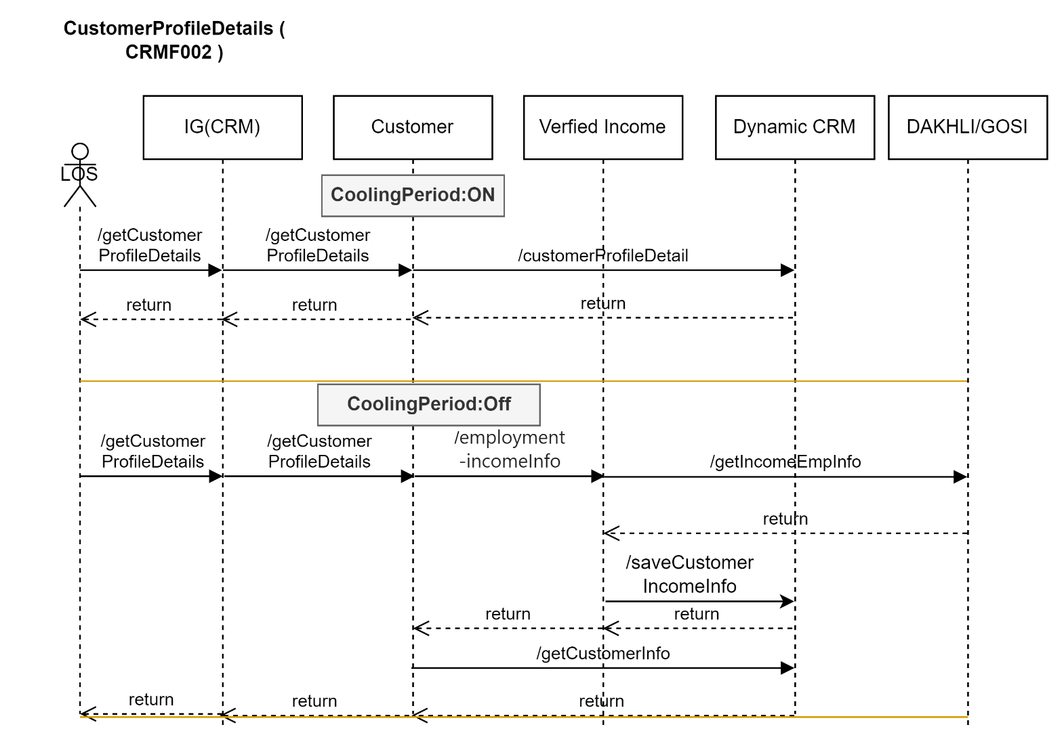

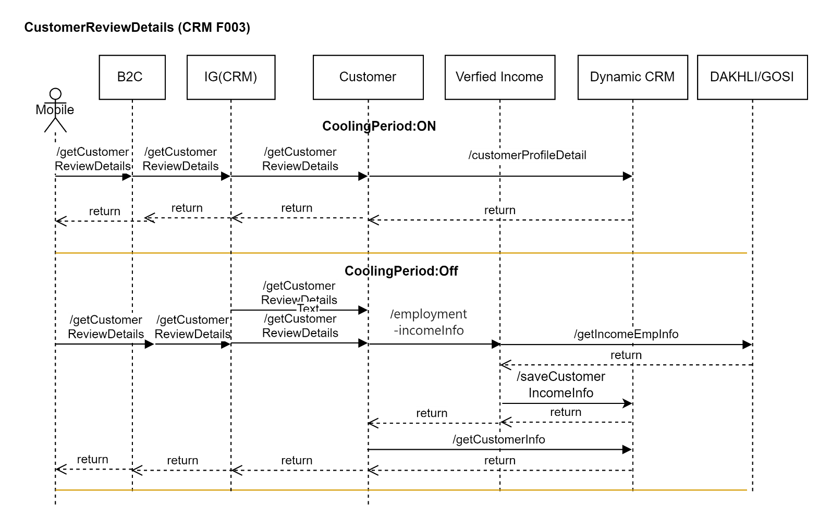

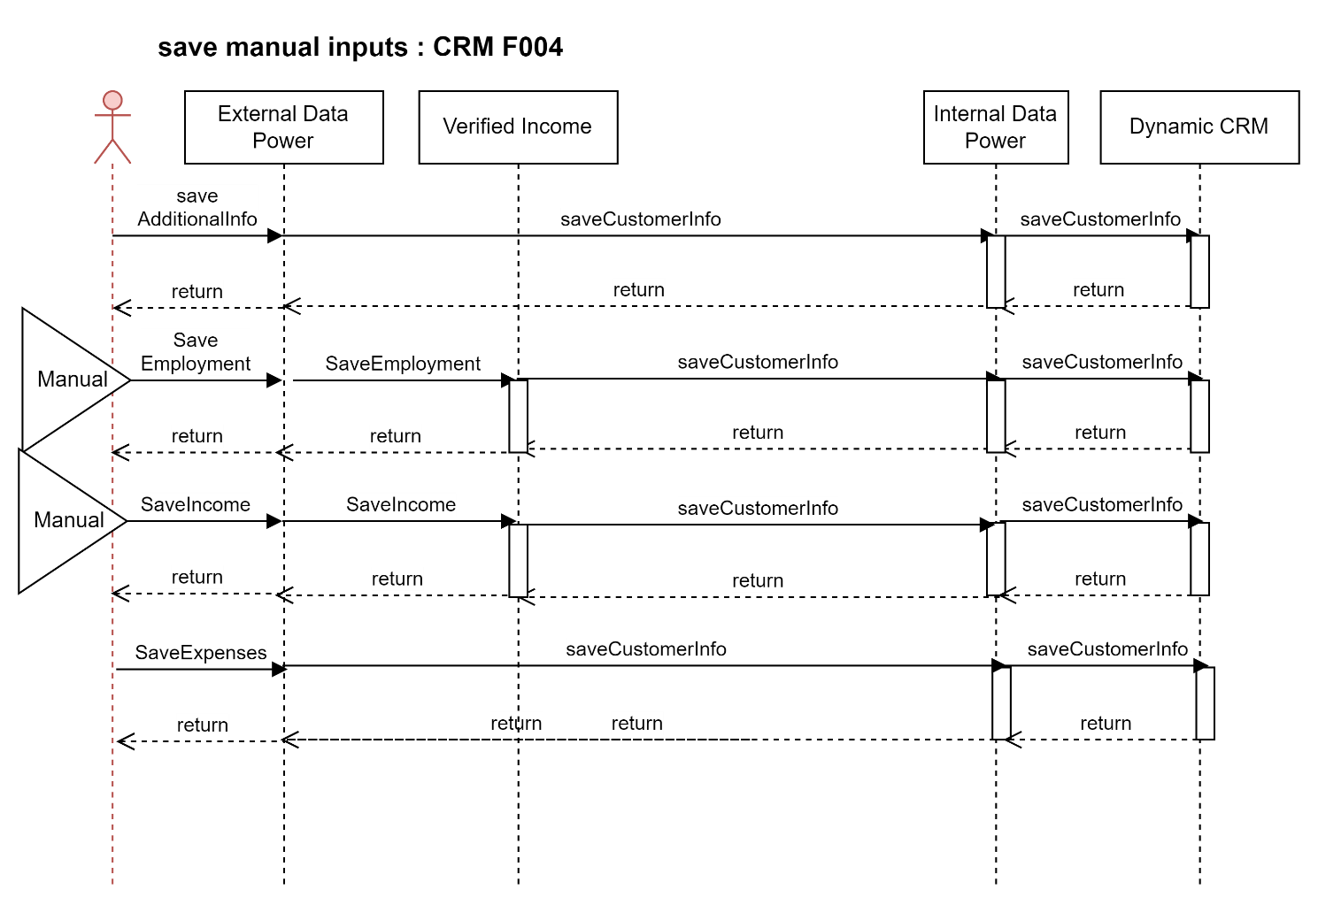

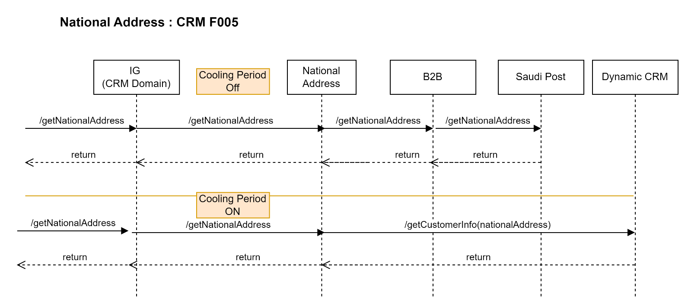

|  |  |  |  |  |  |
| --- | --- | --- | --- | --- | --- |
| **System Provider** | **Action** | **Request** | **Response** | **Type** | **Description** |
| **CRM** | /saveCustomerInfo |  |  |  | Refer IRD  CRM-EMK-DIG001  This api will be exposed by CRM to emkan. Emkan will call this api to save customer related information in Dynamic CRM.  Below objects will be passed as part of this request.  "basicCustInfo","addInfo","salInfo","expInfo","empInfo","autoLeaseCustomerInfo",ibanInfo","buyOutInfo","naInfo","companyInfo","loanDetails" |
| **CRM** | /getCustomerInfo |  |  |  | Refer IRD  CRM-EMK-DIG001  This api will be exposed by CRM to emkan. Emkan will call this api to get customer profile information from Dynamic CRM.  Below objects will be passed as part of this request to fetch customer profile.  "basicCustInfo","addInfo","salInfo","expInfo","empInfo","autoLeaseCustomerInfo","arbAccounts","ibanInfo","buyOutInfo","naInfo","companyInfo","loanDetails" |
| **CRM** | /saveCustomerInfo |  |  |  | Refer IRD  CRM-EMK-DIG001  This api will be exposed by CRM to emkan. Emkan will call this api to update customer profile information in Dynamic CRM.  Any object which need no update will be passed as null.  Below objects will be passed as part of this request to update customer information.  "basicCustInfo","addInfo","salInfo","expInfo","empInfo","autoLeaseCustomerInfo","arbAccounts","ibanInfo","buyOutInfo","naInfo","companyInfo","loanDetails" |
| **Kafka** | Kafka Topic | Request mentioned in  CRM-EMK-DIG003 |  | Kafka topic | When there is any update in CRM through api /SaveORUpdateCustomerInfo. KAFKA Will Listen to CRM DB to retrieve updated records and push updated data to Kafka topic and Ejada MW will listen to this topic and update other core system (LMS).  Below objects will be passed as part of this update request to update customer profile. And this objects will be pushed to Kafka topic.  "basicCustInfo","addInfo","salInfo","expInfo","empInfo","autoLeaseCustomerInfo","arbAccounts","ibanInfo","buyOutInfo","naInfo","companyInfo","loanDetails" |



**IRD for reference**

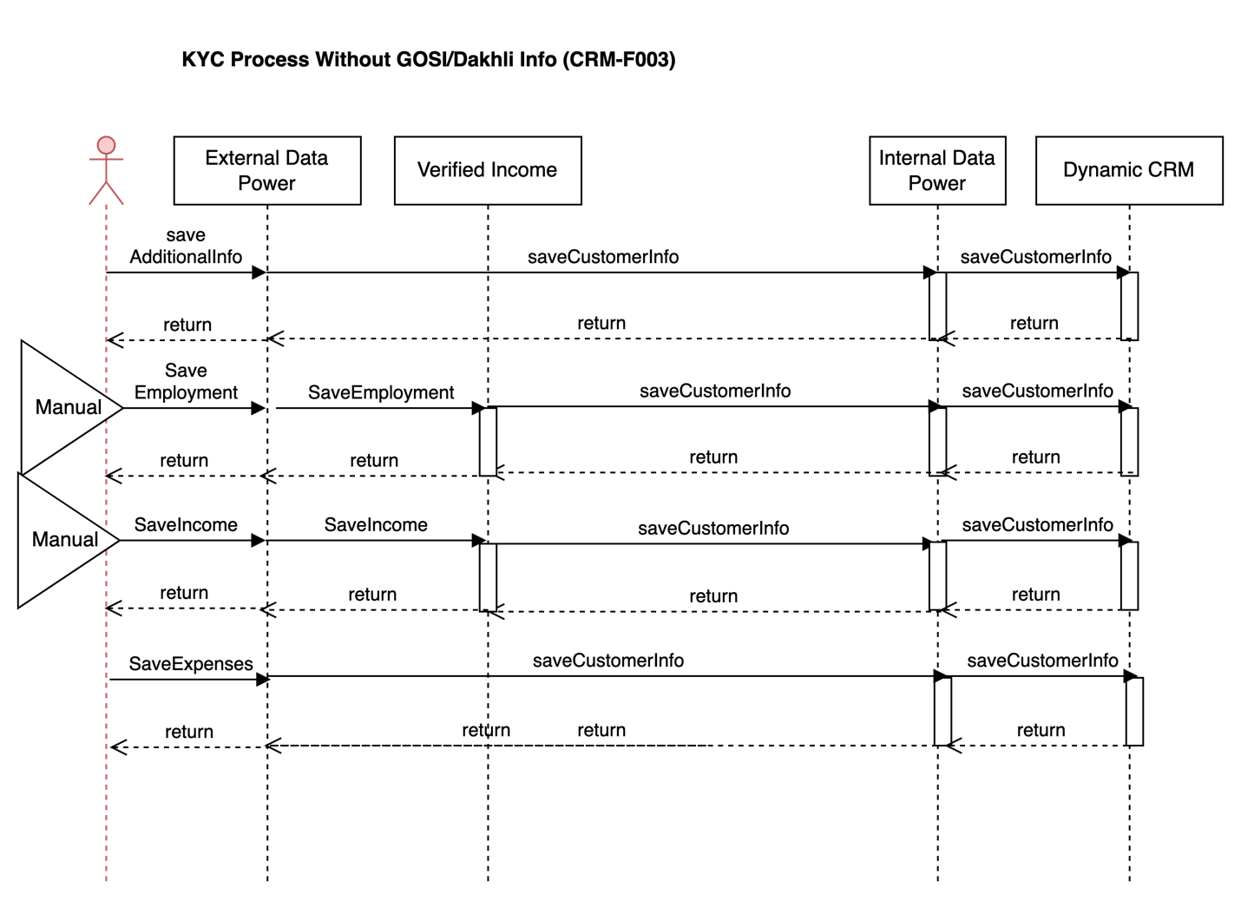

* Description

|  |  |  |  |  |  |
| --- | --- | --- | --- | --- | --- |
| **System Provider** | **Action** | **Request** | **Response** | **Type** | **Description** |
| Customer | /saveAdditionalInfo | asIs | asIs |  | This will internally calls /saveCustomerInfo with **additionalInfo object** in the request to save the information into CRM DB. |
| Customer | /saveIncome | asIs | asIs |  | This will internally calls /saveCustomerInfo with **salInfo object** in the request to save the information into CRM DB. |
| Customer | /getCustomerReviewDetails | asIs | asIs |  | This will internally calls /getCustomerInfo and it will fetch the information from CRM DB. |
| Customer | /saveExpenses | asIs | asIs |  | This will internally calls /saveCustomerInfo with **expInfo object** in the request to save the information into CRM DB. |
| Customer | /saveEmployment | asIs | asIs |  | This will internally calls /saveCustomerInfo with **employmentInfo object** in the request to save the information into CRM DB. |
| Customer | /getCustomerProfileDetails | asIs | asIs |  | This will internally calls /getCustomerInfo to fetch the information from CRM DB. |
| **CRM** | /getCustomerInfo |  |  |  | Refer IRD  CRM-EMK-DIG001  This api will be exposed by CRM to emkan. Emkan will call this api to get customer profile information from Dynamic CRM.  Below objects will be passed as part of this request to fetch customer profile.  "basicCustInfo","addInfo","salInfo","expInfo","empInfo","autoLeaseCustomerInfo","arbAccounts","ibanInfo","buyOutInfo","naInfo","companyInfo","loanDetails" |
| **CRM** | /saveCustomerInfo |  |  |  | Refer IRD  CRM-EMK-DIG001  This api will be exposed by CRM to emkan. Emkan will call this api to update customer profile information in Dynamic CRM.  Any object which need no update will be passed as null.  Below objects will be passed as part of this request to update customer information.  "basicCustInfo","addInfo","salInfo","expInfo","empInfo","autoLeaseCustomerInfo","arbAccounts","ibanInfo","buyOutInfo","naInfo","companyInfo","loanDetails" |

# product Eligibility check

* Diagram

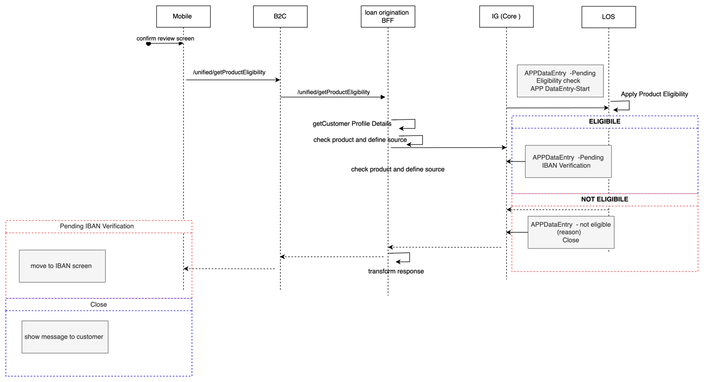

* Description

|  |  |  |  |  |  |
| --- | --- | --- | --- | --- | --- |
| **System Provider** | **Action** | **Request** | **Response** | **Type** | **Description** |
|  |  |  |  |  |  |

1. Description

# IBAN Verification

Design Overview

* Diagram

TBD

* Description

# Upload Document Flow

Design Overview

* Diagram

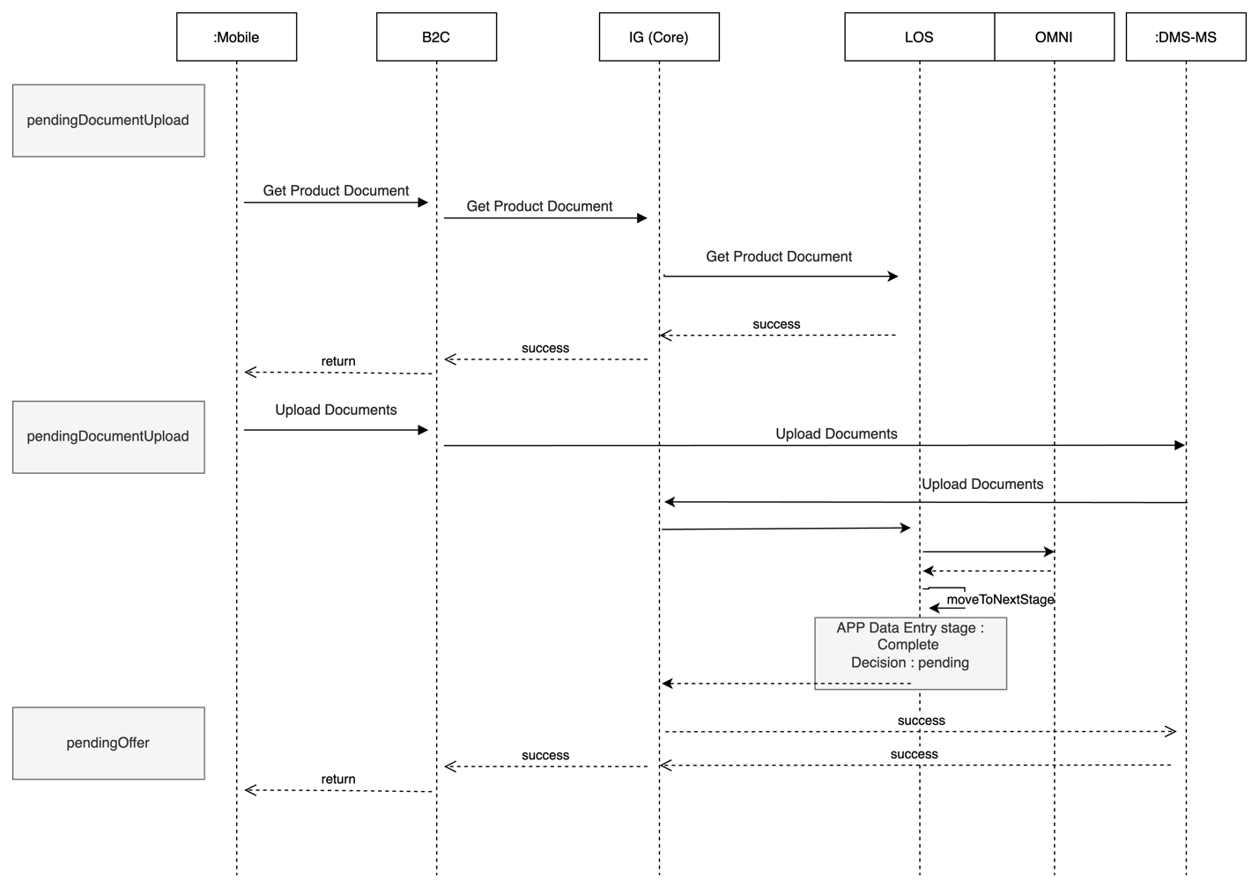

* Description

|  |  |  |  |  |  |
| --- | --- | --- | --- | --- | --- |
| **System Provider** | **Action** | **Request** | **Response** | **Type** | **Description** |
|  |  |  |  |  |  |

# **Deployment and Security View**

TBD

# 

# Appendix A - Architectural Decisions

|  |  |  |  |
| --- | --- | --- | --- |
| Subject Area |  |  |  |
| Architectural Decision |  |  |  |
| Issue or Problem Statement |  | | |
| Assumptions |  | | |
| Motivation |  | | |
| Alternatives |  | | |
| Decision |  | | |
| Justification |  | | |
| Implications |  | | |
| Derived requirements |  | | |
| Related Decisions |  | | |

|  |  |  |  |
| --- | --- | --- | --- |
| Subject Area |  |  |  |
| Architectural Decision |  |  |  |
| Issue or Problem Statement |  | | |
| Assumptions |  | | |
| Motivation |  | | |
| Alternatives |  | | |
| Decision |  | | |
| Justification |  | | |
| Implications |  | | |
| Derived requirements |  | | |
| Related Decisions |  | | |

# Appendix D – Failing Retry Policy

|  |  |  |  |  |
| --- | --- | --- | --- | --- |
| **System** | **Error Code** | **Retry Mechanism** | **Max Number of Retry** | **Alternative after Pass Max No of Retry** |
| Emkan Services | Not http “200” | Exponential back off  Starting with interval 5 mins | 20 | Create Jira ticket |
| “Newgen”,MW | Not http “200” | Retry every 10 min | 20 | Create Jira ticket |

# Appendix E – Cooling Period

|  |  |  |
| --- | --- | --- |
| **Stage/Type** | **Cooling Period** | **System Owner** |
| IVR |  |  |
| signing contract | 24 h |  |
| generate Sanad |  |  |
| Sanad approval | 24 h |  |
| commodity sales maker | 24 h |  |
| commodity delivery |  |  |
| document custody |  |  |

# Appendix R – Risks

|  |  |  |
| --- | --- | --- |
| **Stage/Type** | **Risk** |  |
|  |  |  |
|  |  |  |
|  |  |  |

# Appendix I – General Impacts

|  |  |  |
| --- | --- | --- |
| **owner** | **stage** | **impact** |
| MW |  |  |
|  |  |  |
|  |  |  |